**AK74**

Hip fire:

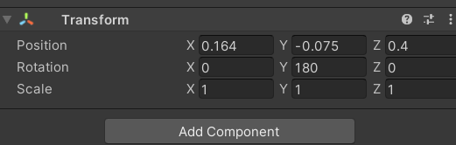

ADS:

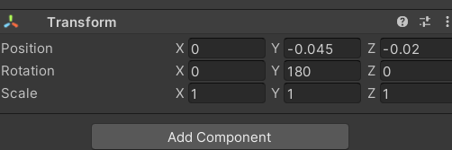

**M1911**

Hip fire:

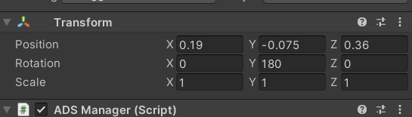

ADS:

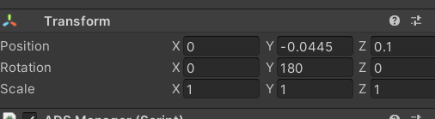

**Uzi**

Hip fire:

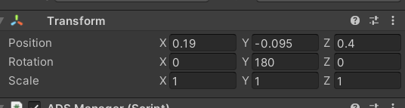

ADS:

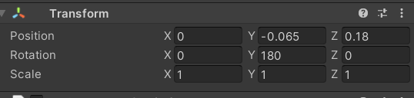

**RPG7**

Hip fire:

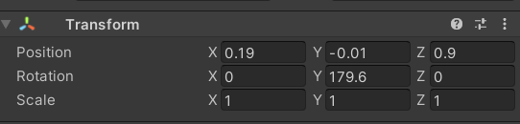

ADS:

